**Fall 2023: CS5720 Neural Networks & Deep Learning - ICP-5**

**Assignment-5**

**NAME:RAJYALAKSHMI GOTTIPATI**

**STUDENT ID:700745186**

Github Link: <https://github.com/rajigottipati/ICP_5.git>

Video link:<https://drive.google.com/file/d/1KmAgPsZmnbReTGmCGbY48UNrVnvgdP7l/view?usp=drive_link>

1. **Implement Naïve Bayes method using scikit-learn library**

Use dataset available with name glass

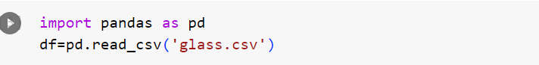

Use train_test_split to create training and testing part

Evaluate the model on test part using score

1. **Implement linear SVM method using scikit library**

Use the same dataset above

Use train_test_split to create training and testing part

Evaluate the model on test part using score and classification_report(y_true, y_pred)

**Which algorithm you got better accuracy? Can you justify why**

In my opinion, Naive bayes gave better results when compared SVM in terms of accuracy, precission, recall, f1-score.

As the data has 6 classifiers and wasn't transmitted into upper dimension, the SVM couldn't produce better results.

SVM would've given better results, had the data got transmitted using kernel option.

Summarizing, if one has to choose between naive bayes and plain SVM , choosing Naive bayes would be better.